Service Now Project Documentation

Introduction

- Project Title: Educational Organisation Using ServiceNow

Team Members:
  - Manchinti Kavya Sree
  - Yadadhala Kalyan Reddy
  - Navarasala Lakshmi Prasanna
  - M Madhavi

Project Overview

Purpose: To develop a robust Educational Management System using
ServiceNow to manage admissions, student progress, and institutional data with automated workflows and form configurations.

Features:
- Online admission form with approval workflow
- Student and teacher data management
- Academic progress tracking dashboard
- Notifications for task status and approvals
- Role-based access control for admins, teachers, and students

Architecture

Frontend:
- Developed using HTML, CSS, and JavaScript
- UI built through ServiceNow UI Pages and Catalog Items

Backend:
- Business logic implemented via ServiceNow Script Includes, Business Rules, and Flow Designer

Database:
- Tables created using the Table module in ServiceNow
- Data stored in platform-native schema with relationships and references

Setup Instructions

Prerequisites:
- ServiceNow Developer Account
- Personal Developer Instance (PDI)
- Basic knowledge of ServiceNow Studio

Installation Steps:
Step 1: Sign in at https://developer.servicenow.com
Step 2: Request and activate your Personal Developer Instance Step 3: Create Update Set → Tables → Forms → Process Flows Step 4: Deploy Client Scripts for automation

Folder Structure (Logical in Studio)

EducationalOrganisation/
├── Tables/ │
├──x_edu_student │
├──x_edu_teacher │
├──x_edu_admission │
└──x_edu_progress ├──
UI Pages/ │
├──admission_form │
└──student_dashboard
├── Script Includes/ │
└──AdmissionWorkflowUtils
├── Client Scripts/ │
└──validate_form.js └──
Styles/
└── styles.css

Running the Application

To run the application:
- Login to your ServiceNow PDI

- Navigate to the created application

- Use the left navigation pane to open modules such as:
  - Admission Form
  - Student Records
  - Progress Dashboard
- Perform form submissions and automation testing

API Documentation
- GET /api/x_edu_org/students
- Response:
- { "student_id":"STU102", "name":"A.Chaithanya",
"department":"ComputerScience"
- }

Authentication
- Role-based access is implemented using admin, teacher, and student roles, managed through ServiceNow Access Control Rules (ACLs).

User Interface
- Designed with HTML, CSS, and JavaScript using ServiceNow UI Pages for a clean and responsive layout.
- Includes dashboards, admission forms, student profiles, and result tracking interfaces.

- Role-based access displays relevant modules for admin, student users.
teacher, and

Testing
- Manual testing was done through the ServiceNow form submission interface.
- Validations verified via onChange and onLoad client scripts.
- Fields were tested for automation, data flow, and visual updates.

Screenshots or Demo
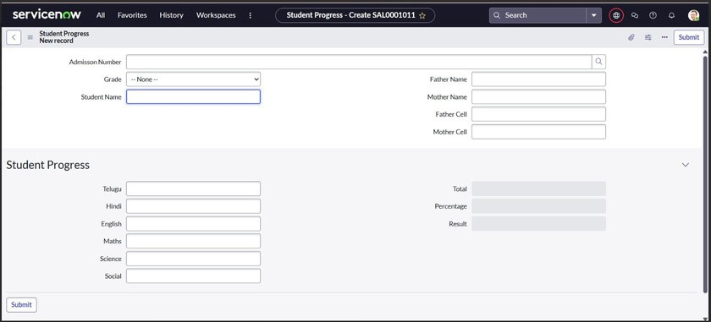
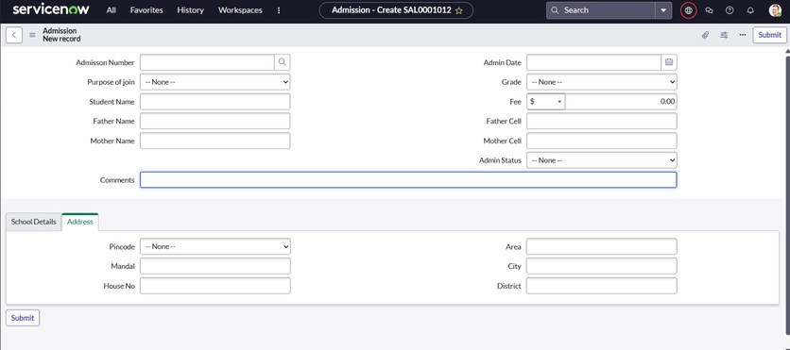
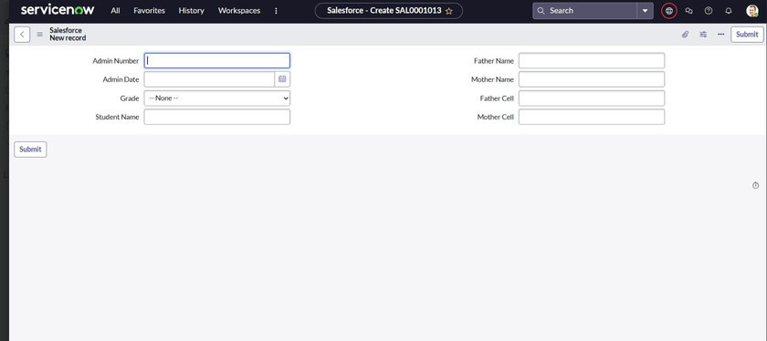

Known Issues
  - Form layout may vary slightly on different devices.
  - Client Scripts dependent on exact field naming — ensure accuracy.

Future Enhancements
  - Add role-based user dashboards
  - Integrate notifications (email/SMS) for admission status
  - Extend to manage teacher data and fee structure
  - Add reporting dashboards using ServiceNow Performance Analytics

